1. Bernoulli – Facet IV – Generating Explanations / Drawing Conclusions
- Reasoning Skills
Learners must understand the underlying theoretical cause for the evidence (phenomenon).
Task Analysis:
1. Understand the principle/theory
2. Understand and evaluate the explanation
3. Reflect on the strengths and weaknesses of the explanation
- Assess the strength of the explanation
- Identify inconsistencies
4. Make a selection
- Description
Engineers use scientific principles to design the shape of airplane wing. Bernoulli’s Principle suggests that fast flowing air creates an area of low pressure while slow moving air creates relative high pressure. How could you use this principle to explain how an airplane flies? Which statement below is true?

- The shape of an airplane's wing causes air to travel over the top of the wing faster than under the wing, which makes the air pressure above the wing less than the pressure beneath the wing.
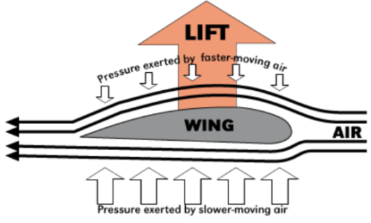
- In order to fly, the force of lift has to exceed the force of gravity. Therefore, there is jet equipment under airplane wings to push the airplane up.
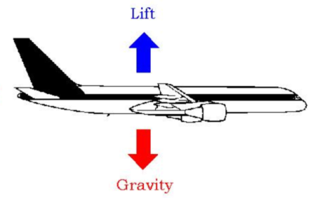
- Because the shape of airplane wings is like birds’ wings and the airplane wings are much bigger than the aircraft itself, the airplane can fly easily. In addition, there is jet equipment behind the airplane wings to push the airplane forward.


- Rubric
Score | Response
1 | A
0 | B or C

3. Brown Trout – Facet III – Reasoning from Evidence to Conclusions
- Reasoning Skills

Learners must draw justified inferences by comparing independent or dependent relationships.

Task Analysis:
1. Interpret graph.
2. Compare relationships
3. Induce a general statement about the relationships among data that summarize the evidence

- Description

Use the data in the graphs above to answer the following question: How is the Brown Trout population related to the pond water temperature?
The Brown Trout population _____________________________________.
A. is not related to the pond water temperature.
B. deceases after the pond water reaches a certain temperature.
C. tends to increase as the pond water temperature increases.
D. is highest when the temperature is the highest.

- Rubric
Score | Response
1 | B
0 | A, C, or D

4. Cans of Water – Facet III – Reasoning from Evidence to Conclusions
- Reasoning Skills
Learners must interpret the results of an investigation to induce a general statement about the results.
Task Analysis:
1. Understand the experimental design and goal
2. Understand the results of the investigation
3. Interpret one or more graphs
4. Recognize patterns in the data
5. Draw a valid, evidence-based conclusion
- Description
Equal amounts of tap water were poured into four cans of identical shape and size. The cans were made of different materials A, B, C and D. A thermometer was inserted into each can. The cans were then placed in an open field on a sunny day.
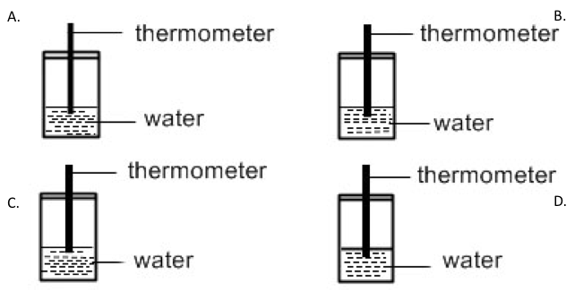

The graph below shows the temperature change of the water in each can after 20 minutes.
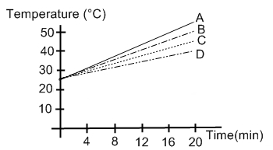
Based on the graph, which of the materials A, B, C or D should be used to make a box to prevent ice cubes from melting too quickly?

- A
- B
- C
- D
- Rubric
Score | Response
1 | D
0 | A, B, or C

5. City Birds – Facet V – Coordinating Theory & Evidence
- Reasoning Skills
In this item, learners must coordinate theory and evidence in such a way so as to draw inferences about causal relationships.
Task Analysis:
1. Understand the theory
2. Interpret Evidence
3. Coordinate evidence and conclusions
- Description

The table below shows the number of birds of a particular color living in a northern city where the amount of snow per year was declining.

 | Year 1 | Year 5 | Year 10
White birds | 100 | 50 | 25
Gray birds | 50 | 75 | 100
Black birds | 50 | 50 | 50

Evolutionary theory suggests that populations of organisms change over generations to adapt to their environments. How could you use evolutionary theory to explain the data above? Circle the statement that provides the best explanation.

A. The number of white birds declined because there was less snow and the birds were no longer camouflaged, and more were killed by predators.

B. The number of white birds declined because there was less snow and the birds no longer needed the white feathers.

C. The number of gray birds increased because the gray color was warmer.

D. The number of black birds stayed about the same because color has no impact on getting killed by predators.
- Rubric
Score | Response
1 | A
0 | B, C, or D

7. Evolution – Facet IV – Generating Explanations / Drawing Conclusions
- Reasoning Skills

Learners must coordinate theory and evidence to explain phenomena. They must seek an underlying theoretical cause for the evidence.

Task Analysis:
1. Understand theory
2. Explain evidence/phenomenon

3. Construct (select) a theory based argument that is aligned with theory and accounts for experimental outcomes and/or observed phenomena
- Description

Evolutionary theory suggests that populations of organisms change over generations to adapt to their environments. For example, the development of DDT-resistant corn earworms can be explained through evolutionary theory as follows:

Years ago spraying corn crops with a chemical called DDT killed almost all of the corn earworms that would infest corn crops. The few corn earworms that survived were DDT-resistant. These surviving earworms were able to reproduce more DDT-resistant earworms. Eventually, spraying with DDT killed only a few of the corn earworms.

Which of the following phenomena could be explained using evolutionary theory? Select the best answer.

A. Organisms have long life cycles

B. Over time spraying with chemicals can kill insects

C. Medicine helps people with diseases live longer

D. Over time a population of organisms could have better sight

E. Treating infections with antibiotics could lead to bacteria that are resistant to antibiotics
- Rubric
Score | Response
1 | E
0 | A, B, C or D

13. Newton – Facet IV – Generating Explanations / Drawing Conclusions
- Reasoning Skills

Learners must understand the theory or law well enough to draw inferences that account for stochastic relationships.

Task Analysis:

1. Understand the theory

2. Understand the comparison/experimental context

3. Construct (select) an argument that is aligned with the theory and accounts for the experimental outcomes or observed phenomena
- Description

One of Newton’s laws suggests that a force (a push or pull) is equal to the mass of the object applying the force multiplied by the acceleration (how the speed of the object is changing every time interval). This law is expressed by: Force=Mass × Acceleration.

a. Andy throws a baseball and a softball on the playground. According to Newton’s laws, which statement below is true? (Baseball=140g; Softball=200g)
- If Andy throws a baseball and a softball horizontally with the same force, a softball would have more acceleration than a baseball.
- If Andy throws a baseball and a softball and he wants to make sure two balls have the same acceleration, he needs to use more force on softball.
- If Andy throws a baseball twice and he uses more force the first time than the second time, the ball he throws the second time will have more acceleration.

b. Another of Newton’s laws states that for every action there is an equal and opposite reaction. How could you use this law, to describe the phenomenon that two very large football players pushed against each other but neither moved?

- Rubric

a.
Score | Response
1 | B
0 | A, or C

b.
Score | Response
2 | Two players pushed against each other using the same force (strength). That is, the product of the mass and acceleration were the same for them.
1 | Their mass (or acceleration) was equal.
0 | Wrong answer e.g., they pushed against each other at the same speed.
14. Organisms – Facet V – Coordinating Theory & Evidence
- Reasoning Skills
In this item, learners must evaluate their theories in light of new observations.
Task Analysis:
1. Evaluate initial theory
2. Recommend changes to theory so as to reconcile theory and evidence
- Description
Joan has a theory that all living organisms need oxygen to help obtain the energy they need to live. She just read about some new organisms growing in the very deep ocean where there is no oxygen that use sulfur to obtain the energy they need to live. How should she revise her theory?
A. Joan does not have to revise it, because organisms in the deep ocean do not matter.
B. Joan’s theory could be that all living organisms need oxygen or sulfur to help produce the energy they need to live.
C. Joan’s theory could be that all living organisms need sulfur to produce energy to live.
- Rubric
Score | Response
1 | B
0 | A or C
17. Plant Growth – Facet II – Hypothesis Testing
- Reasoning Skills
Learners must observe the experimental situation and formulate a question that can direct an investigation. In this case, the learner is selecting a question that is being investigated.
Task Analysis:
1. Observe the experimental situation
2. Identify factors that vary
3. Select question that is directing the investigation
- Description
A student will measure and record the growth of two flowering plants every other day for 10 days. According to the diagram, which question is being investigated?
- Do flowering plants grow better when watered with salt water?
- How much fertilizer do flowering plants need?
- Does fertilizer added to the soil lead to taller flowering plants?
- How tall do flowering plants grow?
- Rubric
Score | Response
1 | C
0 | A, B, or D.

18. Plant Growth Chart – Facet III – Reasoning from Evidence to Conclusions
- Reasoning Skills

Learners must interpret the results of an investigation and draw a justified conclusion based on that data.

Task Analysis:
1. Understand the experiment design
2. Summarize patterns in data table

3. Draw a justified conclusion / Induce a general statement about the relationships among data which summarizes that evidence
- Description
Plant Group | Amount of Light per Day  (hours) | Average Growth in One Week (centimeters)
1 | 4 | 1
2 | 6 | 4
3 | 8 | 6
4 | 10 | 3

The chart above shows data collected when the same types of potted plants were placed in sunlight for different lengths of time. All other variables, such as the type of plant, size of the pot, soil type, amount of water and fertilizer were kept constant.
Which of the following would be a reasonable conclusion based on the evidence?
- There is best amount of light per day in terms of the average growth of plants
- The amount of light does not affect growth
- The more sunlight a plant receives, the greater the rate of plant growth.
- The more sunlight a plant receives, the slower its rate of growth.
- Rubric
Score | Response
1 | A
0 | B, C, or D.
19. Roy’s Lifeboats – Facet II – Hypothesis Testing
- Reasoning Skills
Learners must exhibit the ability to correctly identify and manipulate all relevant variables in order that empirical evidence may be produced that will allow one to make predictions and answer questions.
- Task Analysis
1. Understand research question
2. Identify what data need to be gathered
3. Recognize possible confounds
4. Control variables to determine effect of independent variable
5. Determine how much measurement is needed
6. Assess quality of data against what is needed
- Description
Roy wants to find out if a toy lifeboat floating in a basin of salt water can hold more passengers (pennies) than a lifeboat floating in a basin of fresh water. He wrote a materials list and the first step of his investigation, but he is not sure what to do next.
Roy uses the following steps to find out if having salt in the water affects the number of passengers a lifeboat can hold.
- Get two basins of water
- Fill one with salt water and one with fresh water
- Put a toy lifeboat in the fresh water and carefully add pennies into the boat one at a time until it sinks
- Count and record the number of pennies that sank the boat
- Put the lifeboat in the salt water and carefully add pennies into the boat one at a time until it sinks
- Count and record the number of pennies that sank the boat
- Compare the number of pennies it takes to sink the lifeboat in fresh water to the number it takes to sink the lifeboat in salt water
How could Roy improve his experiment? Choose one best answer.
- He should put the pennies in two at a time
- He should use different lifeboats made from different materials in the salt and regular water
- He should repeat the fresh water and salt water trials and average the results for each
- He should put a toy lifeboat in the salt water first.
- Rubric
Score | Response
1 | C
0 | A, B, or D
23. Vitamin C vs. B12 – Facet V – Coordinating Theory & Evidence
- Reasoning Skills
Learners must evaluate a theory in light of an experimental conclusion, reconcile new evidence with prior beliefs and (if required) revise one’s theory and generate new predictions.
Task Analysis
1. Interpret the experiment
2. Reflect on strengths and weaknesses of the theory and evidence (experimental outcomes)
3. Assess theory and evidence for correlational relationship
- Description
Martina has a theory that Vitamin C helps to cure common colds. She tests her theory by studying people with colds. She randomly selects 150 people who have colds. Then she divides the group of 150 into three different subgroups. The first subgroup of 50 people takes Vitamin C every day until their colds go away. The second subgroup of 50 people takes Vitamin B12 every day until their colds go away. The third subgroup of 50 people takes neither Vitamin B12 nor Vitamin C until their colds go away.
Ave number of days with a cold
Vitamin C people 13 days
B12 people 14 days
No vitamin people 13 days

Based on the evidence, which of the followings can we conclude?
A. The evidence shows that Vitamin C helps to cure common colds
B. The evidence shows that Vitamin C may help to cure common colds better than Vitamin B12
C. The evidence shows that Vitamin C has no different effect on curing common colds than Vitamin B12 or no vitamins.
- Rubric
Score | Response
1 | C
0 | A or B
26. Baking a Cake – Facet II – Hypothesis Testing
- Reasoning Skills
Learners must identify a test that correctly identifies and manipulates all relevant variables in order that empirical evidence may be produced that will allow one to answer question
Task Analysis:
1. Identify what data need to be gathered
2. Recognize possible confounds
3. Control variables to determine an effect on the dependent variable
- Description
John decided to bake a cake. The cake recipe called for butter for the shortening, sugar for the sweetening, and white flour. John decided to make a change to the recipe.
- He used margarine instead of butter for the shortening
- He used honey instead of sugar for the sweetening, and
- He used brown whole wheat flour instead of regular white flour
The cake turned out great. It was so moist. John thought that the reason the cake was so great was the honey. He thought that the type of shortening (butter or margarine) or the type of flour really didn’t matter. What should he do to test his idea? (Circle the best answer)
A. Bake the cake again but use sugar instead of honey, and still use the margarine and brown whole wheat flour.
B. Bake the cake again but this time use sugar, butter, and regular white flour.
C. Bake the cake again still using honey, but this time using butter and regular white flour.
- Rubric
Score | Response
1 | A
0 | B or C
30. Wind Farm – Facet III – Reasoning from Evidence to Conclusions
- Reasoning Skills
Learners must have the ability to interpret the results of an investigation and to draw a conclusion.
Task Analysis:
1. Recognize patterns in the data
2. Draw a justified conclusion based on that data
- Description
Many people believe that wind should replace oil and coal as a source of energy for producing electricity. The structures in the picture are windmills with blades that are rotated by the wind. These rotations cause electricity to be produced by generators.
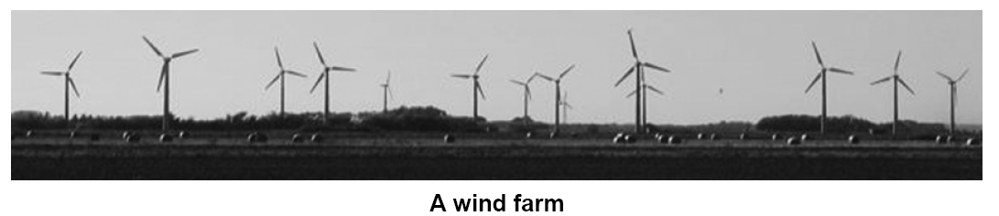
The graphs below show the average wind speeds in four different places throughout a year. Which one of the graphs indicates the most appropriate place to establish a wind farm for generating electricity? Circle your answer.
- Rubric
Score | Response
1 | C
0 | A, B, or D
31. Wooden slope – Facet II – Hypothesis Testing
- Reasoning Skills
Learners must understand how to design a test of a hypothesis that correctly identifies and manipulates all relevant
Task Analysis:
1. Understand task goal
2. Identify what data need to be gathered
3. Determine how much measurement is needed for reliability
- Description
A group of students are given a stopwatch and are asked to measure the time that the ball takes from the edge of the table to hitting the ground after being released at a height (h) of 400 mm.
They discuss what to do:
Student A: “We can roll the ball once from h = 400 mm and measure the time. Once is enough.”
Student B: “Let’s roll the ball twice from height h = 400 mm, and measure the time for both rolls.”
Student C: “I think we should release the ball more than twice from h = 400 mm and measure the time.”

Which student do you agree with more? (Circle one) A B C

Explain your choice.

- Rubric
Score | Response
2 | B or C, they need to make sure that the measure that they get is consistent (or they can get more accurate answer).
1 | B or C, incorrect or no explanation  A, they will know the answer to the question
0 | A, no explanation

34. Spring Experiment – Facet III – Reasoning from Evidence to Conclusions
- Reasoning Skills
Learners must have the ability to interpret the results of an investigation and to draw justified inferences/conclusions based upon that data
Task Analysis:
1. Recognize patterns in the data
2. Construct (identify) a scientific argument based upon evidence showing how the evidence supports the conclusion
- Description
The diagram below shows an experimental setup using two springs, Spring P and Spring Q. The springs were exactly the same except they were made of different materials.
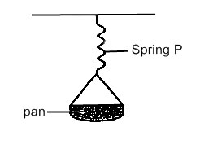

SPRING P SPRING Q
Similar numbers of marbles were placed in each pan and the length of the spring was recorded. The results of the two springs are shown in the graph below.
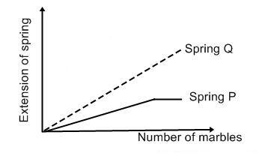
Based on the information provided and the graph, the following statements were made by four pupils.
Alice : Spring Q was stronger than Spring P.
Bala : Spring P extended less than Spring Q for the same number of marbles added.
Christine : Both springs had reached their maximum extended length.
Dollah : Both springs had the same original length.
Who had made the correct statement?
- Alice only
- Bala only
- Alice and Christine only
- Bala and Dollah only
- Rubric
Score | Response
1 | D
0 | A, B, or C

